Experiment 1: Uniform Acceleration

Amanda Wei

505106664

04/06/2019

Thursday 8am

Steve Mendoza

John Field

**Plots**

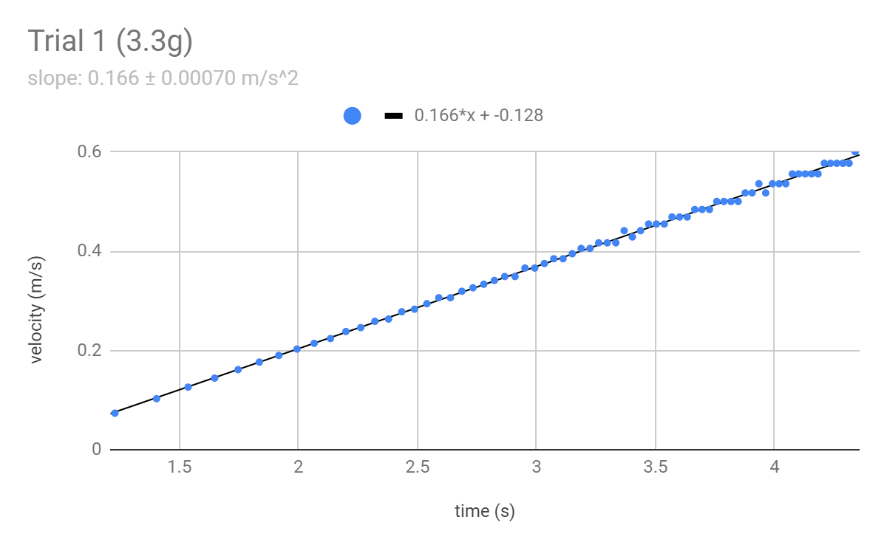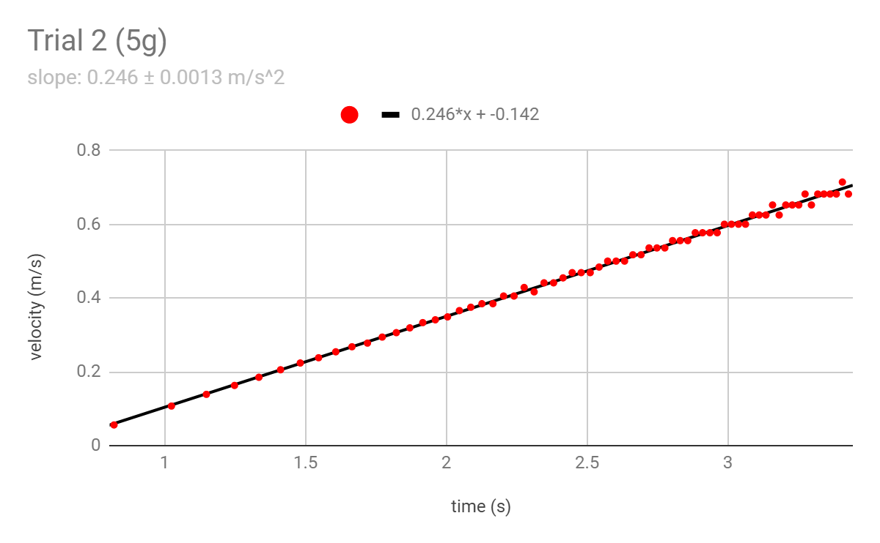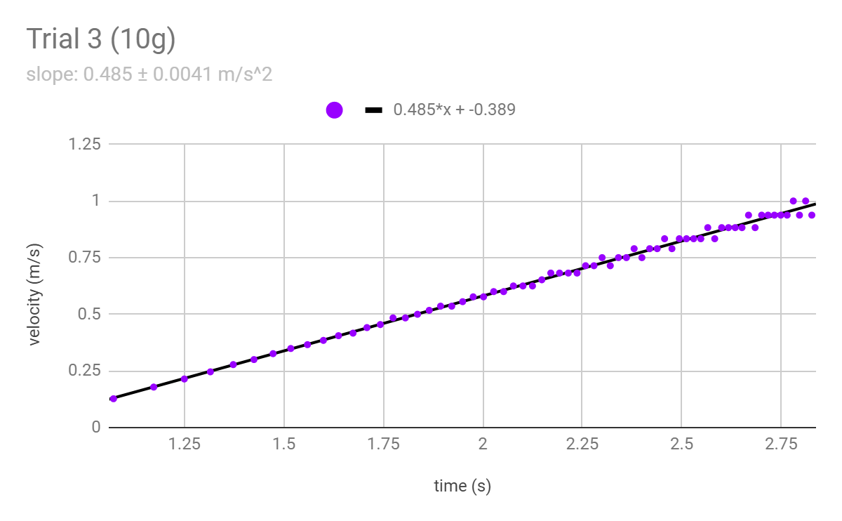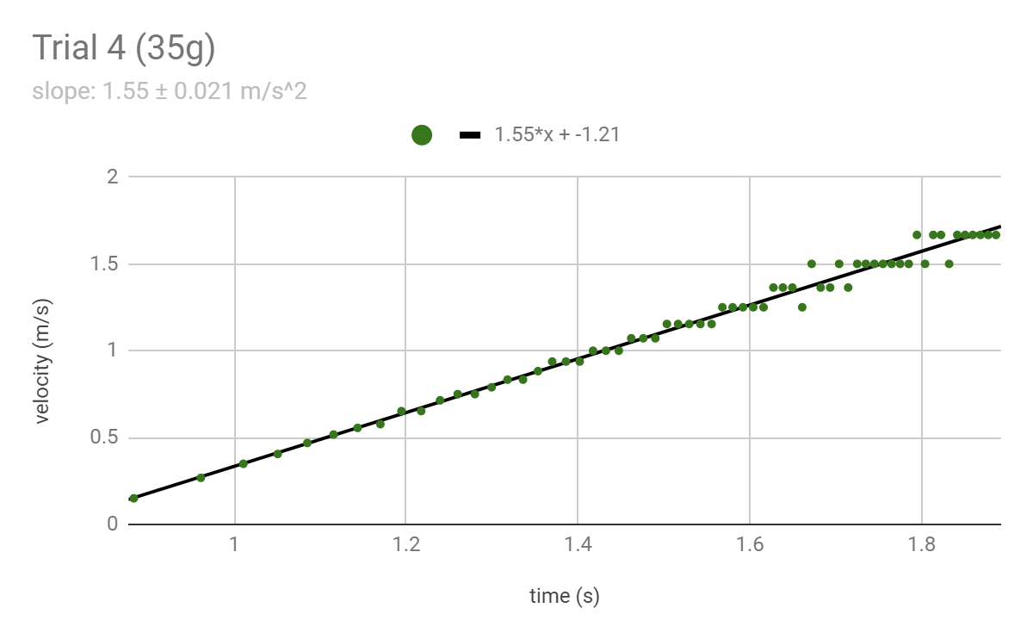

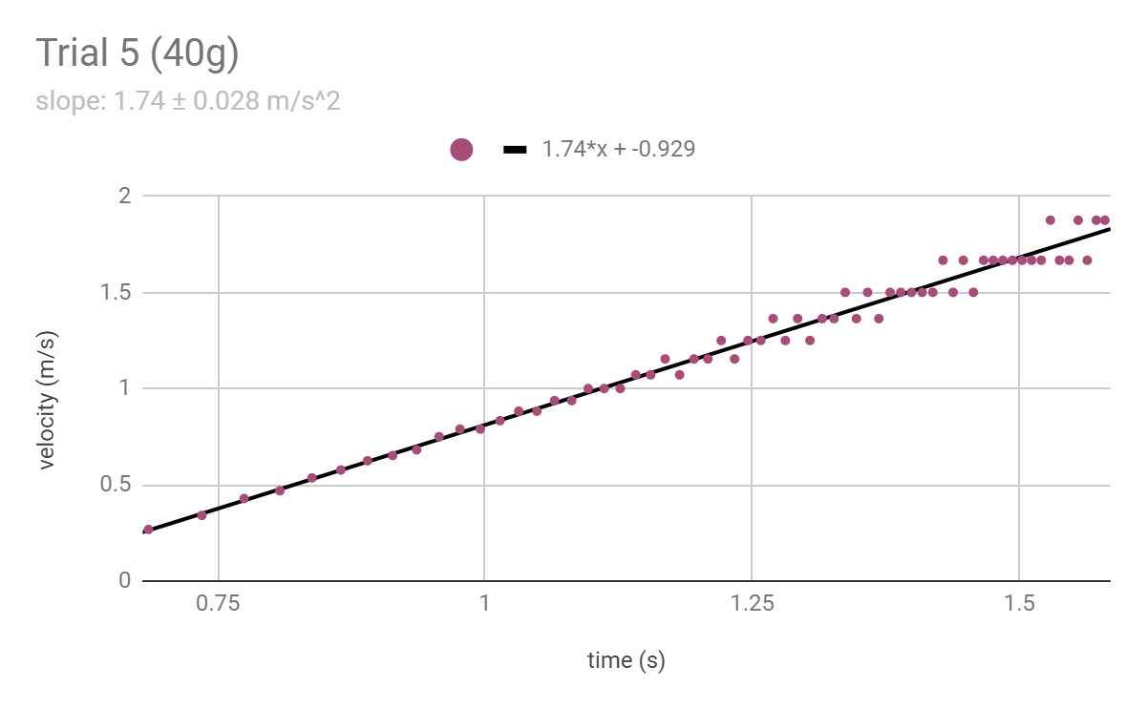

**Data Table**

The following data on the hanging and glider masses were collected during the experiment, while data fit acceleration came from performing linear regression on the data in Google Sheets. The predicted acceleration comes from the formula $a=\frac{mg}{M+m}$. The constant g is defined to be $g=9.7955±0.0003 m/s^{2}$.

|  |  |  |  |  |
| --- | --- | --- | --- | --- |
| Trial | Hanging Mass  *m (g)* | Glider Mass  *M (g)* | Fit Acceleration $a_{fit} (m/s^{2})$ | Predicted Acceleration $a_{predict} (m/s^{2})$ |
| 1 | 3.3 ± 0.05 | 178.50 ± 0.05 | 0.166 ± 0.00070 | 0.178 ± 0.0029 |
| 2 | 5 ± 0.05 | 178.50 ± 0.05 | 0.246 ± 0.0013 | 0.267 ± 0.0030 |
| 3 | 10 ± 0.05 | 178.50 ± 0.05 | 0.485 ± 0.0041 | 0.520 ± 0.0038 |
| 4 | 35 ± 0.05 | 178.50 ± 0.05 | 1.55 ± 0.021 | 1.607 ± 0.0080 |
| 5 | 40 ± 0.05 | 178.50 ± 0.05 | 1.74 ± 0.028 | 1.794 ± 0.0088 |

**Derivations**

Variables:

* M (g): mass of glider
* m (g): hanging mass
* T (N): tension in string

Summing up all forces acting on the hanging mass (gravity and tension) using Newton’s second law, we get that

$mg-T=ma$

Using $T=Ma$, we can solve for *a*.

$mg-Ma=ma$

$mg = a(M+m)$

$a=\frac{mg}{M+m}$

Then to derive the uncertainty in acceleration, we use the formulas provided in ii.2.1 and we have:

* For addition of two values x and y, the propagation of uncertainty is given by:

$δf=\sqrt{{(δx)}^{2}+{(δy)}^{2}}$

* For multiplication or ratio of two values x and y, the propagation of uncertainty is given by:

$δf=|f_{best}|\sqrt{{(δx/x_{best})}^{2}+{(δy/y_{best})}^{2}}$

Then the uncertainty of the numerator and denominator we denote $δ(mg)$ and $δ(M+m)$.

From the above formulas, we have:

$δ(mg)=|mg|\sqrt{{(δm/m)}^{2}+{(δg/g)}^{2}}$

$δ(m+M)=\sqrt{{(δM)}^{2}+{(δm)}^{2}}$

So the propagation of the uncertainty of their ratio is:

$a=\sqrt{{(\frac{δ(mg)}{mg})}^{2}+{(\frac{δ(M+m)}{M+m})}^{2}}$

Plugging in the expressions for $δ(mg)$ and $δ(M+m)$,

$δa=|a|\sqrt{{(\frac{δm}{m})}^{2}+{(\frac{δg}{g})}^{2}+\frac{{δM}^{2}+{δm}^{2}}{M+m}}$

**Conclusions**

In this lab we measured the downward acceleration of various masses and from the time measured per block count, we determined plots of velocity vs. time for each. Performing linear regression on the data, we found that the slope (acceleration) of the block was roughly linear. Each value of the fitted acceleration which we found is slightly less than the predicted value, because the predicted value was calculated under the assumption of frictionless conditions. However, in the experiment there was friction in both the rope and the glider, so the mass accelerated slower than it would have without friction. This is a systematic error that can be minimized by using better instruments (such as an air track with close to zero friction), but it will always be present.

**Extra Credit**

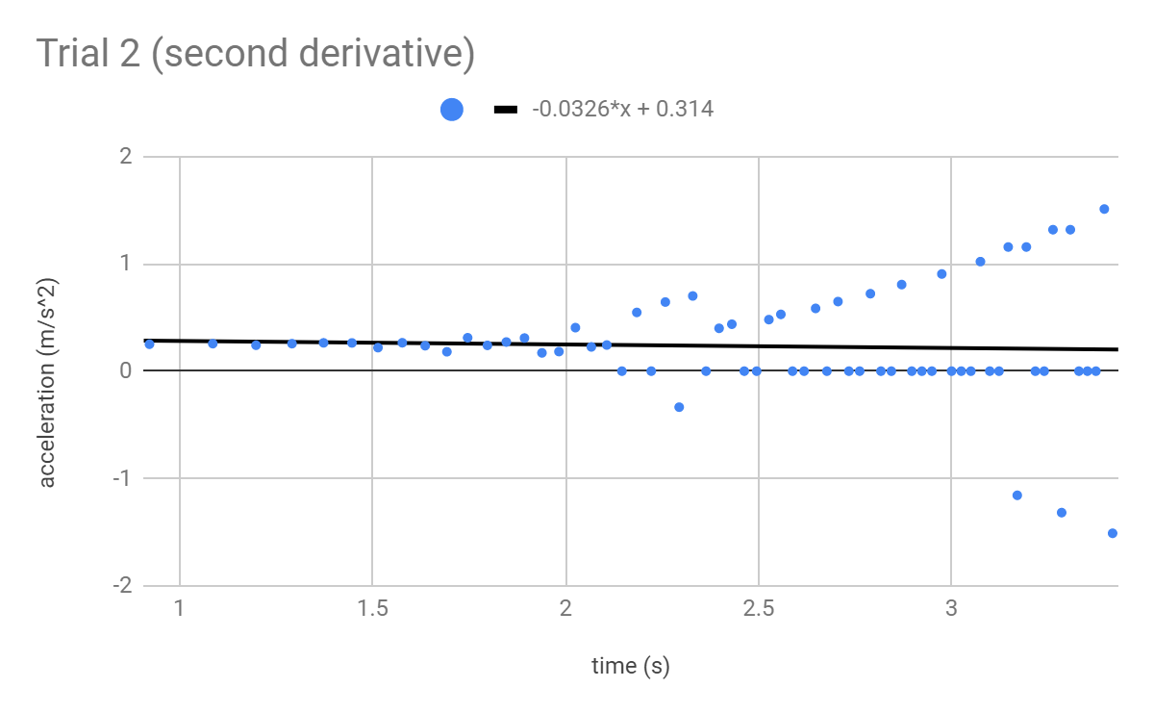

From running STDEV() and passing the list of acceleration as the parameter, we get a standard deviation of 0.52 m/s^2. The line of best fit is close to horizontal because the slope of this line of best fit measures the derivative of acceleration which we expect to be close to zero. However, the standard deviation is comparable to the actual value because of the diverging acceleration data points towards the right side of the plot.

**Presentation Mini-Report**

Nuclear fusion research began in the 1940’s as an offspring of rapid developments in nuclear fission, and both were of great interest primarily for weapons and defense purposes.1 Today, fusion is heralded as the energy source of the future, promising clean and abundant sustainable energy which will combat global warming while keeping up with rising energy demands. However great the promises of fusion are, there are great hurdles to overcome before it can be achieved. Current experimental research today gravitates towards two general methods by which to achieve fusion: magnetic confinement and inertial confinement.

One of the primary challenges to achieving fusion is the containment of the plasma as it undergoes fusion. The pressure and temperature conditions under which fusion occurs is comparable to that at the center of stars, placing a lot of stress on the material used to contain it. One solution is to levitate the plasma in a magnetic field, such as that produced in a toroidal solenoid. The current running through the coil can also serve as supplemental heating in addition to a primary source used to heat the deuterium-tritium fusion fuel. This kind of magnetic confinement device is known as a tokamak, while the stellarator uses a similar technique to confine hot plasma. Compared to tokamaks, stellarators boast greater plasma stability, making it easier to control and monitor. However, its complex shape makes it difficult to design and build, so in this regard the tokamak is more promising.

The second, newer line of research into inducing fusion is inertial confinement, which focuses lasers or ion beams onto a miniscule “pellet” of deuterium-tritium fuel, such that the heating created at the surface “explodes outwards generating an inward-moving compression front or implosion that compresses and heats the inner layers of material.”2 At the center of the pellet, pressures can reach up to one thousand times its liquid density, such that the heat from the resulting fusion can be recycled to reheat the surrounding fuel and create a rather self-sustaining reaction.

A combination of these two techniques is another front in nuclear fusion research being pursued in national research facilities such as SNL, LANL, and has found its way into the private sector, spearheaded by pioneering companies such as General Fusion and Helion Energy. This approach seeks to use a magnetic field to hold the plasma as it is compressionally heated by lasers.

While new and better fusion devices can be designed and desirable features of old ones can be combined to make other more powerful machines, developments in other regards such as material science can considerably affect the efficiency of an entire class of fusion devices. For example, the development of a steel tape coated with yttrium-barium-copper oxide has paved the way for building smaller and stronger magnets which can create a greater magnetic field, allowing the plasma to be compressed further.3 This alleviates some of the stringent demands on input energy required to achieve ignition—the point at which the fusion fuel can undergo a chain-reaction which is necessary for positive net energy output.

Though there is promising research underway for the various fusion devices and techniques, many roadblocks stand in the way of a clean fusion future, one such issue is the scarcity of tritium, which is conventionally used in combination with deuterium for fuel. While deuterium is abundant in the oceans and is found in nature, what tritium is available comes from cosmic rays and nuclear tests conducted in the twentieth century. It is hopeful that one day a deuterium-deuterium reaction will be achieved, the temperature and pressure requirements are much higher. One solution is a layer of tritium about a meter thick which will surround the reaction and absorb neutrons ejected from the D-T fusion reaction such as to be transformed into tritium and helium. This can create an additional source of tritium, but if not enough is produced, supplementary processes must be used to provide the rest. Overproduction creates problems with handling, storage and transport.

Billions of government and private investor’s dollars are being poured into research which currently centers around meeting confinement time and compression velocity demands with lower input energy cost and greater efficiency.

Word Count: 694

**Bibliography**

1. Brief History of Fusion Power. *LPPFusion.* 2019.
2. Nuclear Fusion Power. *World Nuclear Association.* 2019.
3. Dev, Hannah. Nuclear fusion on brink of being realised, say MIT scientists. *The Guardian.* 2018.